To access the backend code open the file notebook.ipynb. Model training is done in this file.

To Access front end code open app.py .

Then Templates code of front end are in Templates folder .

The static file has all static elements, CSS and Java Script Files used in the code.

The Data set used is in archived Folder. The data set is taken from Kaggle platform.  
  
To run the code need to give prompt by copying the address of the folder where the code is with python app.py   
  
Example :

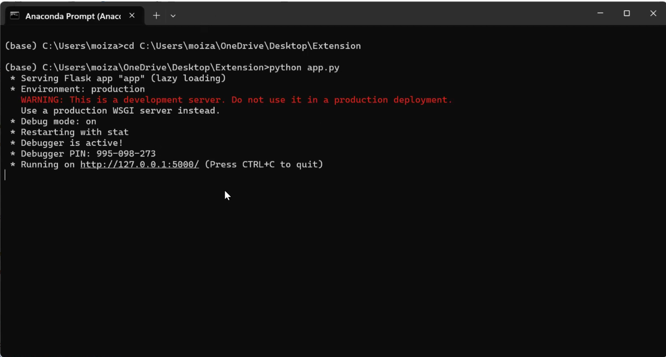   
Now copy the url generated to access the website to test the model.  
  
The project to run smoothly recommended to be accessed in Jupiter note book, And run the code prompt use Anaconda Prompt.